Shabbos Stories for
Parshas Re’eh 5783
Volume 14, Issue 48 – 25 Menachem Av 5783/August 12, 2023
Printed L’illuy nishmas Nechama bas R’ Noach, a”h
For a free subscription, please forward your request to keren18@juno.com
Past emails can be found on the website – ShabbosStories.com

The Mensch of Malden Mills or The Greatest Kiddush Hashem Story Ever Told

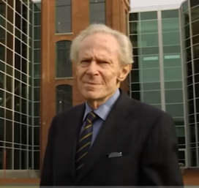
Mr. Aaron Feuerstein and Rabbi Yoel Gold
Rabbi Yoel Gold told a few stories in his video presentation, Illumination, that remind and inspire us to follow in Hashem’s ways and be a light unto the nations. The first story in the video was about the Mensch of Malden Mills.
In December 1995, a boiler exploded in the largest textile factory in the country, the Malden Mills. The entire factory was burned to the ground in a fire so large, that it took an entire week to put out.
At the most festive time of the year for thousands of Mr. Aaron Feuerstein’s largely Christian workforce, they faced the stress of unemployment, the anxiety over providing for their families, and the uncertainty of what lay ahead. Mr. Feuerstein ZT’L, the CEO of the company, a third-generation owner, was about to collect half a billion dollars in insurance for the overnight destruction of his factory. He was faced with a decision: either pocket the money and retire or rebuild the company overseas, saving money on labor, and then pocketing most of the insurance money. Both were great and reasonable options. At 70 years-old, it was commonly assumed he would retire.

A Humanitarian Decision or Kiddush
Hashem that Shocked the World
The next day, Mr. Feuerstein called a press conference to publicly declare his plans. It was televised and many important political figures attended along with the factory employees. Mr. Feuerstein stood up and announced that he would rebuild the factory where it originally stood.
Everyone waited in shock, and he continued with an even more stunning proclamation. “All our employees will be paid their full salaries while the factory is rebuilt.” The entire place erupted in applause filled with intense emotion.
Mr. Feuerstein paid tens of millions of dollars in employees’ salaries during this uncertain time. It was covered on the national news. When he was interviewed and asked why he did such an inspiring act of kindness, he quoted Pirke Avot in Hebrew, “Bimkom she’en anashim, hishtadel lehiyot ish—In a place where there’s no humanity, strive to be a human being.”

A Man of Integrity and Chessed (Kindness)
Mr. Feuerstein was a man of Torah who treated his workers as human beings, not a pair of hands. He did plenty for his employees, as well as the Orthodox community in Boston. Sadly, he passed away after Rabbi Yoel Gold’s interview, but he will be remembered for many years as an anav and a man of integrity and chessed.

Reprinted from the Parshat Vaetchanan 5783 email of Jack E. Rahmey based on the Torah teachings of Rabbi Amram Sananes.

Toras Avigdor Junior
Over and Over and Over…
By Aharon Spetner

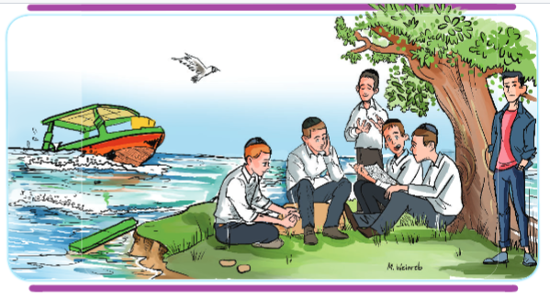
Illustration by Miri Weinreb

The bochurim from Yeshivas Toras Gavriel excitedly got off the buses at Achziv National Park outside the town of Nahariyya. The entire yeshivah was going on a bein hazmanim “tornado” boating trip in the Mediterranean.
As the boys approached the boating club, they were greeted by a worker who started assigning them to the different boats that were awaiting them. The talmidim of shiur beis took their seats on a boat driven by a friendly man named “Ofir”.

Drive Fast or Sow?
“Do you boys want me to drive fast or slow?” Ofir asked them.
“Fast!” all of the bochurim answered at once.
“Excellent,” Ofir said with a huge grin.
Soon all of the boats were sailing away from the coast.
“How far away is Rosh Hanikrah?” Tzviki, the bochur sitting closest to the driver asked.
“Oh, just a few kilometers,” Ofir answered. “Do you want to go in that direction?”
“Yes!!!” the bochurim answered enthusiastically and the boat zipped off to the north.

The Rosh Hanikrah Cable Cars
After a few minutes Ofir slowed the boat down. The boys looked up and saw the famous yellow and red Rosh Hanikrah cable cars hanging from wires above them.
“Look, there you can see the Rosh Hanikrah caves,” said Ofir, pointing at the coast. “Those were formed by the rushing sea water, which cut into the rock.”
Ofir got as close as he safely could to the caves and some of the boys took pictures of the beautiful niflaos haborei. A little while later, Ofir turned the boat south and they began picking up speed again, water occasionally spraying them as they cut through the waves.
“Ofir, look! Are those islands?” asked Tzviki.
“They sure are! Here, I’ll give you a closer look!” Ofir turned towards the small islands about a kilometer off of the coast.
The bochurim admired the view as Ofir circled the islands, when there was a loud crash and the whole boat gave a huge jolt. Everyone suddenly grew very quiet.
“Oh no, we appear to have hit a rock,” Ofir said, as water began to slowly fill the boat. “Everyone, jump out!”

Swimming to the Closest Island
The boys were a bit nervous, but they were all wearing life jackets, so they all climbed overboard and started swimming towards the closest island.
It didn’t take long for the boys to reach the island, where they took off their life jackets and the hot sun began to dry out their clothes.
“Elchonon, is that a daf of Gemara?” asked Levi.
“Yes,” said Elchonon, carefully unfolding a soaking piece of paper in his hand. “I copied the amud that I’m currently holding in so I could learn on the bus.”
Elchonon gently placed the amud Gemara on a rock so that it could dry out.
After a few minutes, Ofir said “they are going to send a boat to pick us up, but it is going to take some time because there is a mechanical issue with the boat’s engine.”
“Levi, do you want to learn with me?” asked Elchonon after his amud Gemara had dried off.
“Sure!” Levi replied as they sat down on a rock and began to learn.
Within a few minutes, all of the bochurim had gathered around and were learning together. It was an easy amud, and after finishing it they went back and started chazering it. Even Ofir, who had nothing else to do, sat listening to them learn.
As the time ticked away, the bochurim kept learning and re-learning the Gemara over and over. Soon, they all knew the whole amud baal-peh and were able to learn without even looking inside.
They were so involved in the learning that they all jumped when they suddenly heard the loud horn of a boat. They looked up and saw a much larger boat than the one they had wrecked about a hundred meters from the tiny island.
Quickly, two men on the boat lowered a rubber raft into the water, and after a few back-and-forth trips, everyone was safely aboard the boat. The men on the boat had brought along bottles of water, which the thirsty bochurim gratefully accepted.
A few minutes later, as they reached the shore, Ofir turned to the bochurim.

“Why Do You Keep Learning?”
“I don’t understand,” he asked. “You spent several hours learning the same thing over and over and over. You obviously knew it well - you were even saying it by heart! Why did you keep learning? What is the point, once you know it?”
“Ofir,” Elchonon said with a smile. “We say every day in Shema ‘V’shinantam.” This means that it’s not enough to learn Torah. The mitzvah is to repeat it over and over and over again. No matter how many times we learn something, every time we learn something new.
And more than that, the Torah becomes more and more a part of us. The Gemara tells us that someone who learns without reviewing it is like someone who plants a field and then never harvests it. The point of learning Torah is not just to learn it - the constant review is the point because that is what makes it a part of who we are!”
Ofir thought about this. He didn’t know much about learning Torah, but what Elchonon taught him made him want to start discovering what it was all about!
Have a Wonderful Shabbos!

Reprinted from the Parshas Vaeschanan 5783 email of Toras Avigdor Junior based on the teachings of Rav Avigdor Miller, zt”l.

The Kind Man Who Helped Me Find My Way
By Avraham Pinter

My name is Avraham Pinter. I was born in 1940 in Tarbes, France, to a family of Holocaust survivors. They were originally from Galicia, Poland, which they fled to escape the pogroms. And then they lived for a time in Berlin, Germany, until they ran to escape the Nazis. Eventually, after I was born, we all made our way to America and settled in Williamsburg, Brooklyn.

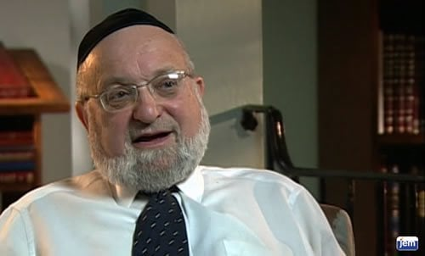
Rabbi Avraham Pinter

I was born in 1940 in Tarbes, France, to a family of Holocaust survivors.
While my father was a youngster living in Berlin in the early 1930s, he had the great fortune to find himself in the company of some of the most esteemed leaders of his generation, notably Rabbi Chaim Heller, who wrote the famous Sefer HaMitzvos based on the order first proposed by Maimonides.
Rabbi Heller was known as a world-class genius, and many people—some of whom were great scholars in their own right—gravitated to him, treated him with utmost reverence, and sought admittance into his study hall, though only a select few made it inside.
Two of those who were part of Rabbi Heller’s inner circle in Berlin were Rabbi Menachem Mendel Schneerson, who would later become the [Lubavitchr] Rebbe, and Rabbi Joseph Ber Soloveitchik, who would later become rosh yeshivah of the rabbinical school at Yeshiva University. Indeed, it was Rabbi Soloveitchik who related to me the following story about my father.
At the time my father was a young chassidic student gifted with a phenomenal memory and a very, very good head. One day he came into Rabbi Heller’s study hall and tried to catch the great teacher’s eye. When he finally succeeded, Rabbi Heller called him over and asked, “Young man, what are you looking for here?”
My father answered, “My teacher sent me here to glean bits and pieces of knowledge.”
Two of those who were part of Rabbi Heller’s inner circle in Berlin were Rabbi Menachem Mendel Schneerson, who would later become the Rebbe, and Rabbi Joseph Ber Soloveitchik.

“Who is Your Teacher?”
“Who is your teacher?” Rabbi Heller asked.
“Rabbi Chaim Tobias,” my father answered, naming the rosh yeshivah of the Kesser Torah Radomsker yeshivah network.
When he heard the name, Rabbi Heller stood straight up to show reverence to my father’s teacher, and then he proposed to quiz my father on his Torah knowledge. He began with “What can I ask you?”
My father, being young, answered (speaking in the third person, as was customary when addressing a sage), “The rabbi can ask me whatever he wants.”
“Is that so?” Rabbi Heller was surprised, but taking him at his word, selected a very difficult Talmudic passage and asked him the meaning.
Without batting an eyelash, my father began an impressive recitation of the various commentaries on this particular passage.

Pointing to the Two Lions
When he was through, Rabbi Heller said, “You can remain here. You passed the test. You can be part of this group. And, if you have any difficulties, you can ask these two lions.” With that he pointed to Rabbi Schneerson, the future Rebbe, and to Rabbi Soloveitchik.
In later years, when my father became famous in his own right, he rarely lavished praise on anyone, but he did tell me that from his encounters with the Rebbe in those years in Berlin he got a glimpse of his greatness. He said to me, “I can testify that the Rebbe knows everything there is to know in Torah. There is nothing that he doesn’t know.”
My father said to me: “I can testify that the Rebbe knows everything there is to know in Torah. There is nothing that he doesn’t know.”
Keeping that in mind makes the story which I will relate next all the more astonishing.
In 1955 my family moved to Crown Heights, and my mother invited her parents, my grandparents, to come and visit our new home. They were elderly people, European, “greenhorns,” not that long off the boat, so to speak. They got onto the New York subway and got off at Kingston Avenue, right by Chabad headquarters at 770 Eastern Parkway.
When they came up from the subway, they were on the even side of the street, and our apartment was on the odd side of the street, so they became a bit confused. Eastern Parkway is very wide at that point, eight lanes, plus an island on either side of the parkway.
They were looking at house numbers, unsure where to go. They saw a Jewish man walking by—he was carrying a Torah book—so my grandfather spoke to him in Yiddish: “My daughter and my son-in-law, Rabbi Pinchas Pinter, just moved here, but I don’t know where their house is.”

“Do You Have the House Number?”
The man asked, “Do you have the house number?”
“Yes, it’s 723.”
“I’ll show you.”
He took them across the entire parkway, and walked with them until they came to the right house.
When they arrived, my younger brother was waiting by the window, and he was shocked by what he saw. When they came into the apartment, he asked them, “Do you know the man who brought you here?”
My grandfather said, “No. He was some nice Jew I met. I told him that I was looking for this address, and he walked us here. It was very kind of him.”
“Zeide, do you know who that Jew is?!”
“No.”
“He is the Lubavitcher Rebbe!”
My grandfather refused to believe it. He said, “A rebbe who goes without an entourage? Who acts like a simple person? Who helps people to cross the street? This is unbelievable!”
My grandfather didn’t realize that this was usual behavior for this rebbe. I personally saw him many a time going into the corner store to buy milk and a newspaper for his mother, who was then living on the corner of Kingston Avenue and President Street. Many time,s I saw him do this, and then walk by himself to bring the groceries to her.
I’ve heard others speak of similar recollections. Rebbetzin Shur, the wife of Rabbi Avraham Shur, told me that when the Rebbe lived in the building on New York Avenue, she saw him helping a pregnant woman, Mrs. Pletchenik, get into the elevator with her parcels. She went up in the elevator, but he walked up the steps.
That’s just the kind of rebbe he was.

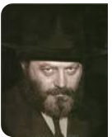
The Lubavitcher Rebbe, circa early 1950s.

Rabbi Avraham Pinter has served as the principal of various yeshivahs in the New York metropolitan area, including the Mirrer Yeshiva, Yeshiva Chaim Berlin, Shaarei Torah and Yeshiva Chofetz Chaim. He has also served as superintendent of the Midtown Manhattan school district. He was interviewed in his home in May 2008.

Reprinted from the archives of “Here’s My Story, part of the JEM Foundation’s “My Encounter with the [Lubavitcher] Rebbe oral history project.

Waiting it Out
By Rabbi Paysach J. Krohn

When Rochel Gold arrived in America with her husband and children, she was determined that her family not succumb to the prevalent American Jewish life of Shabbos desecration, eating non-kosher food and public-school education. This was quite a challenge in 1922!
Mrs. Gold’s first priority was finding a yeshivah for her nine-year-old Yankel. She heard of the Yeshiva Rabbi Yakov Yosef (RJJ) on the Lower East Side, and promptly went with her son to register. She was shocked when the principal told her that they were overcrowded and could not accept her son.
After trying many arguments and lines of reasoning, Mrs. Gold still could not convince the principal to accept her son. Exasperated, she asked, “How long must I wait to get him into your yeshivah?”
The answer shocked her. “Two years!” But she was resolute, so she stated with pride, “If we have to wait, then we will wait.” Mrs. Gold and Yankel sat on one of the steps on the front stoop of the yeshivah.
“Let him hear the children davening,” Mrs. Gold thought. “Let him hear the voice of a rebbi instructing a child. Let him see yeshivah bochurim. We’ll wait right here.”
They sat there for hours, she sewing and he counting the passing cars. During recess, one of the rebbeim noticed her and asked if he could be of assistance. She answered, “I am waiting.” He assumed she was waiting for one of the students. But when he noticed her a few hours later in the very same spot, the rebbi approached her and said, “Excuse me, but whom are you waiting for?”
She replied matter-of-factly, “I am waiting for my son to be accepted into the yeshivah. Can you help?”
The rebbi went to the principal and told him about the lady on the front steps. The principal came to see, but did not say anything because he knew he could not help her.
For three days, Mrs. Gold sat there with Yankel, sewing, talking, praying and waiting. She explained to anyone who would listen that all she was doing was waiting. By the fourth day her wait was over. Somehow, room had been made for Yankel. Yankel attended RJJ, as did his children after him. All of Mrs. Gold’s children, grandchildren and great-grandchildren have remained frum. (In the Footsteps of the Maggid)

Reprinted from the Parshas Va’eschanan 5783 email of The Weekly Vort.
A Still Relevant Sefer
By Rabbi Reuven Semah

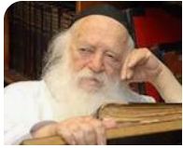

A true story is told by Rabbi Yitzchok Hisiger about a sefer (book) that was released called Siach Hanechama that contains insights into the period of the Three Weeks and commentary on the book of Eicha from Rabbi Chaim Kanievsky zt”l.
As the final touches to the sefer were being made, a certain well-to-do Jew was approached and presented with the opportunity to assist in covering the costs of publication. The potential benefactor thought for a moment and then demurred.

Refuses to Fund the Sefer
“With all due respect,”” he said, “I do not wish to fund your sefer. You see, every day we plead with Hashem to rebuild the Bet Hamikdash. We all believe that any moment, Eliyahu Hanavi can come and inform us of the imminent arrival of Mashiah. Thus, it is a shame to publish such a sefer on the destruction of the Bet Hamikdash and Tish’ah B’Ab because Be’ezrat Hashem, real soon, the sefer will be useless and obsolete. No one is going to look at it and I don’t want to throw away my money for such an endeavor.”
This man’s response was shared with Rav Chaim, who did not agree with it at all.
“He is incorrect,” said Rav Chaim. “Even after Mashiah comes, we will continue to study and learn all the Sefarim that deal with the destruction. The laws of the Three Weeks won’t be erased from the Shulhan Aruch! The Torah of Moshe is eternal. The reason we will still review the details is in order to know and remember what caused the Hurban and what sent us into exile in the first place. This will ensure that we know how to improve ourselves and perfect our characters and so that we will remember what sin can bring about.”
May we speedily witness the coming of the Mashiah, Amen.

Reprinted from the Parshat Va’etchanan 5783 edition of the Jersey Shore Torah Bulletin.

The Power of the Rav’s Tears

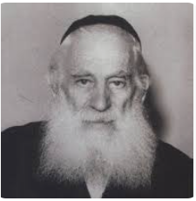
Rabbi Yosef Shlomo Kahaneman

A seventy-year-old man came to the rosh yeshiva of a baal teshuvah yeshiva and said he wanted to do teshuvah. The rosh yeshiva asked him why he wanted to do teshuvah at this point in his life. (It isn't common for people to do teshuvah and to totally change their life around at that age.)
The man explained that his father was burned in Auschwitz, and his mother became irreligious. She sent him to an orphanage, which the Rabbi Yosef Shlomo Kahaneman, the Ponovitzer Rav zt‘l ran. When she visited the orphanage and discovered it was a religious institute, she immediately took her son back home to Tel Aviv.
The next time the Ponovizher Rav visited the orphanage, he noticed that one of the children was missing. The staff told him what happened. The Rav immediately went to the woman's home in Tel Aviv. It was Friday afternoon, but his pain from losing a Jewish child was so great that he couldn't push it off.
When the mother saw the Rav, she said, "If you came to convince me to return our son to the orphanage, I want you to know that there is nothing to talk about! I was in Auschwitz..." and she told him that she abandoned Yiddishkeit. The Ponovizher Rav didn't respond – he just sat there and cried.
When this son turned seventy, he came to the rosh yeshiva of the baal teshuvah yeshiva and said, "The Rav's tears chased me for sixty years, and that's why I am here today to do teshuvah."

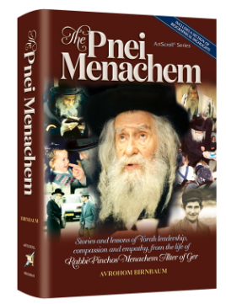

There was an outstanding student learning in Gur, and the rosh yeshiva, the Pnei Menachem zt'l (Rabbi Pinchos Menachem Alter of Ger, 1926-1996), enjoyed speaking with him in learning. The boy's father visited the Pnei Menachem to ask about his son's progress. The Pnei Menachem replied, "He's doing well. He learns well," but didn't elaborate. He didn’t tell him how special his son was.
Soon after, the father returned to the Pnei Menachem and asked why he gave him such a cold report. "The students of the yeshiva told me that you enjoy speaking with my son in learning, and you talk with him all the time. So why didn't you give me a more enthusiastic report when I asked about my son?"
The Pnei Menachem explained, "Parents have to daven for their children, and I didn't want to take that away from you. If I had praised your son, you would feel confident that everything is fine, and you would stop davening for your son's success, which would be a great loss."
The Pnei Menachem added, "I was born from my parent's second marriage. My mother had children of her own before she married my father, the Imrei Emes (Rabbi Avrohom Mordechai Alter, 1865-1948).

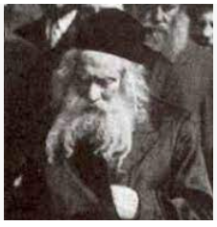
The Imrei Emes

Once, she cried before her husband, the Imrei Emes, that one of her sons was called for the army draft. The Imrei Emes replied with a brachah, "May Hashem help." He davened but didn't tell her she had nothing to worry about and that her son won't be drafted.
"My mother went to her mother and told her how worried she was about her son. Her mother was the sister of the Imrei Emes. So, she went to the Imrei Emes and asked him about her grandson.
The Imrei Emes replied, 'Don't worry. He won't be drafted.' When he gave this havtachah (promise), everyone calmed down, and baruch Hashem, there was a salvation.
"My mother asked the Imrei Emes, 'If you knew my son wouldn’t be drafted, why didn't you tell me? I was so worried.'
"The Imrei Emes replied, 'A mother must daven. I knew there would be a yeshuah, but your tears were needed. If you had known for sure that everything would be okay, you would stop davening and crying, and your tears were needed for the yeshuah!'"
The Pnei Menachem turned to the father, "This is why I didn't elaborate on your son's success. I didn't want you to feel that everything is perfect. A parent must daven."

Reprinted from the Parshas Bamidbar 5783 email of Torah Wellsprings: Collected Torah Thoughts from Rabbi Elimelech Biderman.

